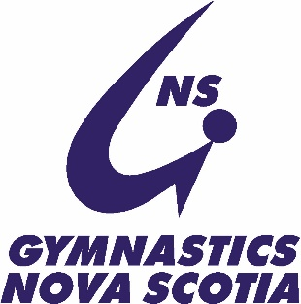

**Gymnastics Nova Scotia 2022 Provincial Championships Schedule:**

Friday April 22nd

**Session 1: MAG Provincial 1 all ages, Provincial 2 all ages, Elite 1, Elite 3, Provincial 3 2010-2011**

**(28 athletes total)**

7:30- 7:45am: General Warmup

7:45- 11:30pm: Competition and Awards

**Session 2: MAG Provincial 3 2009+, Provincial 4 all ages, Junior, Senior (25 athletes)**

12:00- 12:15pm: General Warmup (No event touch permitted)

12:15- 4:00pm: Competition and Awards

**Session 3: WAG Level 8 (18), Level 9 (7), Level 10 (6) (31 athletes)**

4:30- 4:50pm: General Warmup (No event touch permitted)

4:50- 8:30pm: Competition and Awards

Saturday April 23rd

**Session 4: WAG: Argo 3 (20), Tyro 3 (22), Novice 3 (2) (44 athletes)**

7:30- 7:45am: General Warmup (No event touch permitted)

7:45- 10:30am: Competition and Awards

**Session 5: WAG: Argo 4 (9), Tyro 4 (9), Novice 4 (5), Argo 5 (2), Tyro 5 (3) (28 athletes)**

11:00- 11:15am: General Warmup (No event touch permitted)

11:15- 2:00pm: Competition and Awards

**Session 6: WAG: Argo 6 (1), Tyro 6 (30), Novice 6 (15) (46 athletes)**

2:15- 2:30pm: General Warmup (No event touch permitted)

2:30- 5:30pm: Competition and Awards

**Session 7: WAG: Open 6 (6), Tyro 7 (5), Novice 7 (5), Open 7 (4) (32 athletes)**

6:00- 6:15pm: General Warmup (No event touch permitted)

6:15- 9:00pm: Competition and Awards